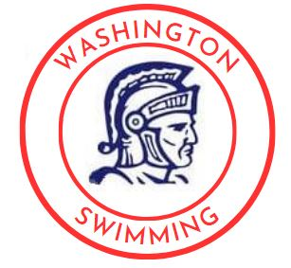
WARRIOR SUMMER SWIM OPPORTUNITIES
Join the Warrior swim coaches this summer to elevate your training
Clinic descriptions and registration links can be found by following the QR code at the bottom of the page or clicking HERE.

Middle/High School Technique & Fundamental Camp
Monday – Thursday, June 12 – July 20 from 5PM-7PM
Open to any swimmer entering middle or high school.

High School Weightlifting & Dryland Conditioning
Monday – Thursday, June 12 – July 20 from 7PM-8PM
Open to any swimmer currently in or entering high school in the fall.

Elementary School Technique Camp
Monday – Thursday from 4PM to 4:45PM
June 12 – June 22 and/or July 10 – July 20
Open to any swimmer currently in or entering elementary school (Entering 5th grade or younger)
Camp contact information:  Coach Matt Sinnott  Email: msinnott@crschools.us | 
*This is a private camp not sponsored by the CRCSD*

