**PTA General Meeting**

**3rd Tuesday / May 21, 2024 – 9:00 a.m.**

Meeting Minutes

***President:*** *Clay Melton called the meeting to order at 9:00 a.m.›*

*Kelley Cole seconds.*

Attendees: Clay Melton, Anthony Betters, Kelley Cole, ShaNell Young, Karen Swanson, Charlotte Butilofer, Shanwa Ripple, Jennifer Gibbons, Dorea Burkamper, Nadine Brock, Nicole Pedron, Kelly Bult, Rebecca Lindwall, Stephanie King, Jennifer Gibbons

Approve Last Meeting Minutes: [April 2024 PTA Meeting Minutes](https://docs.google.com/document/d/17rd89fQj50ddo9MGTQTBtk50NSUxC7C_jUL0SZz8ovE/edit?usp=sharing). Motion to approve by Clay Melton. Seconded by Kelley Cole.

## Principal’s Report: Ian LeMaster

* Skipped as Principal or delegate did not attend.

## Counseling Report: Shawnna Ripple/ShaNell Young

* Students cannot switch from in-person to online after midterms, unless there is a special circumstance
* Leadership for Five Seasons Applications were sent out to all Sophomore students April 1st for participation in the 24-25 school year. Applications are due back to the counseling office April 19th. Leadership of Five Seasons is an organization that works to give students a hands-on learning experience in leadership and community service.
  + Leadership for Five Seasons application Deadline was extended until May 7th
  + If your child submitted an application, they were submitted and accepted and will be receiving information about next steps
* End of Year Dates for 9-11 Grade
  + Here's the schedule from Memorial Day until the end of the school year:
  + **Tuesday, May 28th:** Regular “B” day
  + **Wednesday, May 29th:** Regular “A” day
  + **Thursday, May 30th:** Regular “B” day
  + **Friday, May 31st:** [Adjusted “A” day schedule](https://docs.google.com/document/d/1w8rQrncgj1cUEDFUsf7IcjJhzu9kQxDwZkMrcklzqWs/edit?usp=sharing)
  + **Monday, June 3rd:** Regular “A” day
  + **Tuesday, June 4th:** Regular “B” day
  + **Wednesday, June 5th:** Regular “A” day
  + **Thursday, June 6th:** [Adjusted “B” day schedule](https://docs.google.com/document/d/1w8rQrncgj1cUEDFUsf7IcjJhzu9kQxDwZkMrcklzqWs/edit?usp=sharing) (Final day for students)
* Summer School Info? (Signup Information)
  + We are waiting on final dates from Admin before sharing with students and families
  + This is for students who need to recover credit. NOT for new credit classes
* Senior Transcript Request and Exit Info
  + Please have your Senior look at the Class of 2024 Google Classroom, as it has the link and QR code for transcripts, as well as commencement and technology return information
  + Seniors were given hard copy of this info earlier in May at Senior Homeroom and any that missed were invited to come get a copy from the Counseling Office
  + Mr LeMaster and Cymone sent out email reminders this week as well

## Executive Committee Reports:

* We met and decided to keep the Executive positions for next year the same as last year:
  + President: Clay Melton
  + Vice President: Anthony Betters
  + Co-Treasurers: Kelley Cole / Jennifer Gibbons
  + Secretary: Stephanie King

Vote was taken and the above candidates passed with nine votes.

Motion to disassociate with Iowa PTA:

*~~I motion that the Washington HS PTA disassociates with the Iowa PTA and rename it to the Warrior One Fund. The approved motion from the general meeting on April 16, 2024 to transfer our financial administration to the CRCS Foundation will be done so under the new name of Warrior One Fund, as of June 30, 2024, our fiscal year-end.~~*

*I motion that the Washington HS PTA disassociates with the Iowa PTA and renames to a name TBD by June 30, 2024. The approved motion from the general meeting on April 16, 2024 to transfer our financial administration to the CRCS Foundation will be done so under the new name, as of June 30, 2024, our fiscal year-end.*

Motion edited to allow new name to be decided in committee at a later date. The phrase, “and rename it to the Warrior One Fund” removed from the motion per feedback from the members.

Karen S. abstains from the vote per conflict of interest.

Vote taken and motion passes with eight votes.

CR Community Foundation Committee (Execs) to finalize the details this summer based upon this and the previous month’s votes. Thanks for the support.

Flags Revenue to be gathered by the WAC as we were not able to find a volunteer.

We need a Hospitality Committee Leader as we will lose Dorea after next year.

Note: we are burning reserves now. Cash wise we are fine, but our donations are way down. Next year, we will be able to cover around half of what we spent this year.

### Membership: Anthony Betters

Senior Award Night was a Success. It was an honor to hand out the awards. The PTA is writing a $2000 check to support their graduation awards. Congratulations Washington Seniors! Apr 22, 2024

* Please stay tuned to the new changes for 2024-2025 school year
* Survey please share with any Washington parents as a reminder
* Sharing Social Media Post (<https://www.facebook.com/crwashPTA>) Name will change later this summer.

### Budget: Kelley Cole with Jennifer Gibbons as Shadow

* $2000 planned for Graduation Awards

### Grounds: Christine Erickson

April 20 at 9am Grounds Clean up went well. Thank everyone for their help.

### Hospitality: Dorea Burkamper

* Post Prom was a huge success. Thank you to all who supported!
* Teacher’s Luncheon is scheduled for May 17th. It went really well. Thanks to everyone who helped out!

### Warrior Closet: Amy Rouse

PTA just cut a check to support the warrior closet. Supporting the welfare of our community's children is written into our PTA bylaws and we are happy to support.

Here are the efforts the Warrior Closet is putting together for the summer. Can we help?

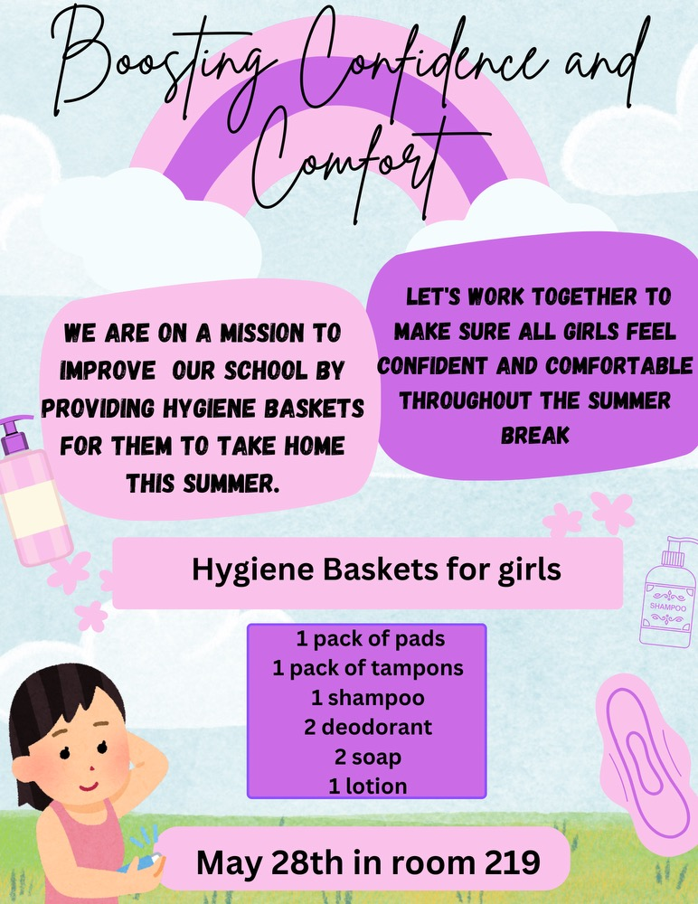

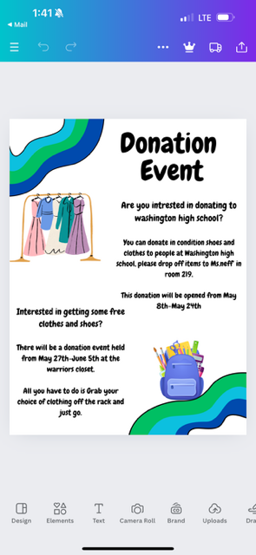

The largest needs are always: **Backpacks**, Wash Gear (tshirts, sweatshirts) chapstick, belts.

Attached my updated info sheet on the closet, feel free to share with the group! Let me know if you have any questions. [Warrior Closet 2023-2024](https://docs.google.com/document/d/1JfT7061yfCB5axmnLjKYuR59s0A67dxigcZcOeDHdxQ/edit?usp=drive_web)

Amy Rouse reachable at [arouse@crschools.us](mailto:arouse@crschools.us), or 319-558-463

### College Connections: Becky Lindwall Notes with Counseling

* No report needed this month.

### Last Ten Minutes: General Questions to Washington Staff and Counselors

* PE
* Fourth Counselor to be hired: Chanell Thomas

**Meeting Adjourned: 9:40 a.m. by Clay Melton seconded by Kelley Cole**

**Any questions or comments?**

**Please contact us at:** [**crwashpta@gmail.com**](mailto:crwashpta@gmail.com)

# Reference Items (Not Discussed in Meeting)

## Volunteer Reference Information

Raptor Volunteering Tracking System,  
<https://apps.raptortech.com/Volunteer/Login/MTE5OTpWb2x1bnRlZXI6ZW4tVVM=>

or reach from the Washington High School Website:  
<https://washington.crschools.us/students-families/parent-teacher-association/>

This link will be posted at the end of each month as a reminder to enter your volunteer hours. Make Washington’s Volunteer hours show up in district records! Go Warriors!

## Washington Counseling Information

<https://sites.google.com/site/cwrcounseling/home>

## Executive Contact Information

Role, Name, Contact Information:

* President, Clay Melton, 319-329-0907  
  or [claymelton@icloud.com](mailto:claymelton@icloud.com)
* Vice President, Anthony Betters, (254) 495-4915  
  or [anthoybettersjr@gmail.com](mailto:anthoybettersjr@gmail.com)
* Treasurer, Kelley Cole, 319-210-6800  
  or [kelleyc7525@gmail.com](mailto:kelleyc7525@gmail.com), & Jennifer Gibbons as shadow for this role
* We need a PTA Secretary!