**Warrior Connect Executive Meeting**

**July 31, 2023 – 9:00 a.m.**

Minutes

## Executive Committee:

Present: Clay Melton, Stephanie King, Dorea Burkamper, Kelley Cole, Anthony Betters, Jennifer Gibbons

* Virtual Public Meeting Times (Tuesday Evening at 7 pm) Which week of each month: Second Tuesday - Agreed Tues Sept 10 @7pm. Executive 9/3 @9AM. 1st Tuesday Exec (morning). 2nd Tuesday Exec (evening).
* Please review Bylaws. Let’s ratify these in September. <https://docs.google.com/document/d/19hMEmsGxUealr-aOCBrRkipZgM6A2d_Rzcsx8_KMSmk/edit?usp=sharing>
* Brochure of Warrior Connect needed - Waiting on QR codes.
  + Check with Cymone for forms to be included with WAC and PPA.
* New Donation Form  
  <https://docs.google.com/document/d/1jYtwxLHK0fDkMRrwjYIYOrLM7XHoPgZk3edvyZrPVvU/edit?usp=sharing>
  + Warrior Connect Donation Needed – Kelley to take Check over soon
  + Logo Ratification needed – should we vote? Selected #2
  + Infinite Campus Addition of Our Form
* Logos Reviewed and the following Logo was chosen for our organization!



(chosen design below)

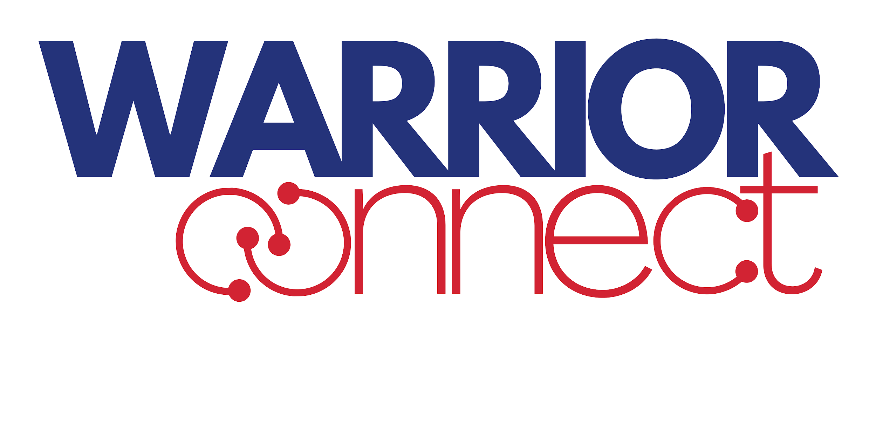

* Marketing / Social Media Plans
  + Facebook name change & add Stephanie (Anthony has permission to do this)Anthony to add Stephanie to FB. Create Twitter account
    - Clay changed Facebook URL but having difficulty with Page Name change - Takes 7 days
  + Create Instagram account. Not for parents.
  + Web page – markups sent to Jason already. We need PTA off of this page soon.
  + Cymone puts out emails to the entire high school. Let’s drop something once a week in August about what we do/benefits. Decide once per month.
  + Need post about name and logo change to: Cymone (via email), and Facebook,and our website. 8/13 5-7 pm Anthony. Need to create schedule. Clay to email.
    - What other posts do we need?
* How did clubs use the money as a condition of the contribution also give membership visibility to the fund usage. Reimbursement by club size? Is a New reimbursement form needed? Special reimbursement by no new form.
* PTA audit status: Tomorrow night. For next year, no audit but a review by the treasurer.
* What Welcome Nights and Events will we cover
  + BIPOC - 8/13 Anthony
  + WAC Welcome Night 8/20
  + Open House Night 9/4
  + Freshman Orientation NIght 8/19
  + Picnic in the Park 8/15?
* Bylaws – Let’s ratify in September
  + Let’s just announce the changes and the link [HERE](https://docs.google.com/document/d/19hMEmsGxUealr-aOCBrRkipZgM6A2d_Rzcsx8_KMSmk/edit?usp=sharing).
  + What changed?
    - “PTA” Removed. Board of Directors (Iowa PTA authority) removed.
    - Elected Officers, Principal and Committee Leads have similar authority
    - Only two of the above and one or more attendees make a “quorum” for a meeting.
    - Membership dues removed. Any attendee is welcome (if they donated or not). We want to be more inclusive to the school.
    - Meetings will be moved from during the day to the evening (per survey feedback)
    - CR Community School Foundation Roles Added
* Survey Feedback
  + Move Public meeting to evening (nearly everyone)
  + Reminders of meetings: Email wins, and Text message is second (if we can do this)
  + Most people don’t want to be recognized for their donations to Warrior Connect
  + Most people like to donate via Vemno or Check

Discussed the need to support Picnic in the park in August 15th and agrees that we could support with $250 donation.

Also discussed Amy’s message for our Warrior Closet and needs there. Donate where we can to support backpacks here too:

Hello Everyone! I will be unable to attend tomorrow's meeting but I have created a Donors Choose project for the Warrior Closet, specifically backpacks! Here is the link if we could share that out!

<https://www.donorschoose.org/project/backpacks-for-our-warriors/8527607/?utm_source=dc&utm_medium=directlink&utm_campaign=project&utm_term=teacher_7998522&rf=directlink-dc-2024-07-project-teacher_7998522&challengeid=21789705>

The Warrior Closet passed out over 200 backpacks last year. This project will at least get us stocked for the beginning of the year!

I would say the beginning of the year needs would be:

* Backpacks
* Notebooks (single subject, wide rule)
* Folders
* Deodorant (mens and womens)

These would be what the big push at the start of the year would be for us!

Please let me know if you have any questions.

Also getting the word out to families that we have the Warrior Closet available.

Thank you!

Amy Rouse

# Reference Items (Not Discussed in Meeting)

## Volunteer Reference Information

Raptor Volunteering Tracking System,  
<https://apps.raptortech.com/Volunteer/Login/MTE5OTpWb2x1bnRlZXI6ZW4tVVM=>

or reach from the Washington High School Website:  
<https://washington.crschools.us/students-families/washingon-warrior-connect-formerly-pta/>

This link will be posted at the end of each month as a reminder to enter your volunteer hours. Make Washington’s Volunteer hours show up in district records! Go Warriors!

## Washington Counseling Information

<https://sites.google.com/site/cwrcounseling/home>

## Executive Contact Information

Role, Name, Contact Information:

* President, Clay Melton, 319-329-0907  
  or [claymelton@icloud.com](mailto:claymelton@icloud.com)
* Vice President, Anthony Betters, (254) 495-4915  
  or [anthoybettersjr@gmail.com](mailto:anthoybettersjr@gmail.com)
* Treasurer, Kelley Cole, 319-210-6800  
  or [kelleyc7525@gmail.com](mailto:kelleyc7525@gmail.com)
* Secretary, Stephanie King, 319-329-9591  
  or [depaul94@gmail.com](mailto:depaul94@gmail.com)
* Need to add committee lead contact info here too for each meeting